Instructions: Show all work to earn full credit on the following exercises. You MAY use any handouts, notes, or homework you have completed prior to the quiz, but must work alone.

- Sketch the following function in a good viewing window. A “good” viewing window will show at least one of the axes and any turns in the graph. It will also include minimal empty space.

  - [3pts] Sketch of Graph:

  - [4pts] Viewing window:

- [3pts] Write a possible equation for the function pictured below.
[Hint: You can check your answer on your calculator]
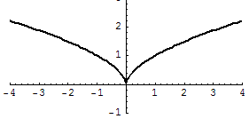

- [2pts] Does the function pictured above appear to be even, odd, or neither? Explain.

- [5pts] Jordan must draw an even function, but only knows part of the graph (shown below). Using full sentences, explain how Jordan can complete the graph of the even function.
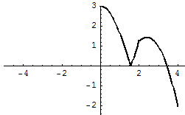

- [3pts] Give example equations for each of the following types of functions:

  - An example of a polynomial function is __________________

  - An example of a radical function is ___________________

  - An example of a linear function is ___________________

